SECTION 260923 – LIGHTING CONTROL DEVICES
- GENERAL
      - RELATED DOCUMENTS
        - Drawings and general provisions of the Contract, including General and Supplementary Conditions and Division 01 Specification Sections, apply to this Section.
      - SUMMARY
        - This Section includes the following:
          - This Section specifies the dimming control and occupancy sensors for lighting systems as shown and the drawing and specified herein for buildings and structures.
          - Provide all labor, materials, and equipment as necessary to complete all work as indicated on the drawings, and as specified herein.
          - The Contractor shall furnish and install a complete dimming control system and occupancy sensor system, as shown on the drawing and specified herein.
        - Related Sections include the following:
          - Applicable sections of Division 26 – Electrical
      - SUBMITTALS
        - Shop Drawings:
          - Dimming control systems
          - Occupancy sensors
        - Operation and Maintenance Data:

          - Dimming control systems
          - Occupancy sensors
      - QUALITY ASSURANCE
        - Wall box dimmers, occupancy sensors, and dimming systems shall comply with all applicable Underwriters Laboratory and ANSI/IEEE Standards.
        - Dimming systems:
          - Equipment shall be fully tested for proper operation prior to shipment from the factory.
- PRODUCTS
      - OCCUPANCY SENSORS

If dimming is involved, install a Leviton wall box dimmer after the occupancy sensor for the appropriate lamps.
        - Wall box occupancy sensors for small offices, storage rooms, copy rooms, etc. shall be:
          - Lutron MSA102 (single relay) for single level lighting and MSA202 (dual relay) for two level lighting
          - Wattstopper DW-100 (single relay) for single level lighting and DW-200 (dual relay) for two level lighting.
          - SensorSwitch WSD PDT (single relay) for single level lighting and WSD PDT 2P (dual relay) for two level lighting.
          - Leviton OSSMT-GDW (single relay) for single level lighting and OSSMT-GDW (dual relay) for two level lighting.
          - Hubbell Building Automation LHMTS (single relay) for single level lighting and LHMTD (dual relay) for two level lighting.
          - Cooper Controls ONW-D-1001-MV-X (single relay) ONW-D-1001-DMV-X (dual relay).
        - Ceiling mount occupancy sensors for small offices, storage rooms, copy rooms, etc. shall be:
          - Lutron LOS-CDT-2000-WH with PP-DV power pack for automatic on control and NTRCS-1 for manual on control
          - Wattstopper model DT-200.
          - SensorSwitch CMR PDT 9.
          - Leviton ODC0S-MDW.
          - Hubbell Building Automation OMNI-BP.
          - Cooper Controls OAWC-DT-120-W and SP20-MV power pack.
        - Ceiling mount occupancy sensors for large offices and conference rooms shall be:
          - Lutron LOS-CDT-2000-WH with PP-DV power pack for automatic on control and NTRCS-1 for manual on control
          - Wattstopper DT-200 sensor and a BZ-50 power pack for automatic on control or BZ-150 for manual on control.
          - SensorSwitch WV PDT 16 with MP20 power pack.
          - Leviton OSW12-M0W sensor and OSP20-RD0 power pack.
          - Hubbell Building Automation LODTRP with UVPP power pack.
          - Cooper Controls OAWC-DT-120-W and SP20-MV power pack.
        - Ceiling mount occupancy sensors for large open offices shall be:
          - Lutron LOS-CDT-2000-WH with PP-DV power pack for automatic on control and NTRCS-1 for manual on control
          - Wattstopper DT-300 series sensors and BZ-50 power packs for automatic on control or BZ-150 for manual on control.
          - SensorSwitch CMR PDT 10 with MP20 power pack.
          - Leviton OSC05-M0W, OSC10-M0W, or OSC20-M0W sensors and OSP20-0D0 power pack.
          - Hubbell Building Automation OMNIUS500, OMNIUS1000, or OMNIUS2000 series sensors and UVPP power packs.

          - Cooper Controls OAC-DT-0501-R, OAC-DT-1000-R, OAC-DT-2000-R and SP20-MV power pack.
        - Ceiling mount occupancy sensors for toilet rooms shall be:
          - Lutron LOS-CDT-2000-WH with PP-DV power pack for automatic on control and NTRCS-1 for manual on control
          - Wattstopper DT-300 series sensors and BZ-50 power packs for automatic on control or BZ-150 for manual on control.
          - SensorSwitch CM PDT 10 with MP20 power pack.
          - Leviton OSC05-M0W, OSC10-M0W, or OSC20-M0W sensors and OSP20-RD0 power pack.
          - Hubbell Building Automation OMNIUS500 and UVPP power packs.
          - Cooper Controls OAC-DT-0501-R, OAC-DT-1000-R, OAC-DT-2000-R and SP20-MV power pack.
        - Wall box occupancy sensor/dimmer for small offices with LED lighting shall be:
          - Lutron MS-Z101-WH.
          - Wattstopper DW-311-W.
          - Leviton OSD10-I0W.
          - Hubbell LHD-IRS-3-N-WH.
      - WALLBOX DIMMERS
        - Wall box dimmers shall be U.L. listed for the required lighting load and shall be capable of operating at full capacity with no adverse effect to the dimmer.
        - Dimmers shall incorporate power failure memory. Should power be interrupted and subsequently restored, the lights will come on to the level they were set at prior to the power interruption.
        - Dimmers shall be equipped with RFI filters.
        - Dimmer faceplate shall snap on the device with no visible means of attachment. At locations with multiple dimmers, one seamless, multigang faceplate shall be provided. Faceplate finish shall be Ivory.
        - Incandescent Dimmers
          - Incandescent wall box dimmers shall be Lutron “Nova CL” series, Lithonia “SLD” series, or Leviton “82000" series.
          - Cooper Controls WBSD-DEC-C2
        - Fluorescent Dimmers
          - Fluorescent wall box dimmers shall be Lutron 3-wire or ecosystem controls for use with Lutron Hi-Lume 3D ballasts.
          - Fluorescent wall box dimmers shall be Leviton “26666” series for use with Advance Mark X ballasts.
          - Cooper Controls WBSD-DEC-C2
        - LED Dimmers

          - LED wall box dimmers shall be Lutron DVSTV-WH for use with 0-10V LED drivers.

          - LED wall box dimmers shall be Leviton IP-710-LFZ-WH for use with 0-10V LED drivers.
      - SYSTEM DIMMERS
        - Dimming Panels

Indicate on the drawings the quantity of dimming modules and quantity of non-dimmed modules.
          - Panels shall also contain branch circuit breakers for individual channels. Circuit breakers shall be U.L. listed under U.L. 489. Branch breakers shall be thermal-magnetic type. Breakers shall have a minimum interrupting rating of 10,000 amps.
          - Panels shall be cooled via free-convection, unaided by fans.
          - Dimmer modules shall respond to control signals following the Square Law dimming curve as published by the IES.
          - Dimmer shall have an integral inductive toroidal filter to limit objectionable harmonics, reduce acoustical noise in incandescent lamps, and limit conducted radio frequency interference on the dimmer panel feed and branch circuits.
          - A positive air gap relay shall be employed with each module to ensure that the load circuits are open when the OFF function is selected at a control station.
          - Panels shall have a minimum of six modules and be expandable up to twelve modules either within one panel or by adding additional panels (controlled thru the first panel).
        - Main Control Panels

Indicate on the drawings the type of main control to be used on the system. If scene controls are required, then the following two paragraphs need to be inserted and a system specified to fit the application.
          - Main control shall have individual controls each module and master control to control all modules simultaneously.
        - Accessory Controls

Indicate on the drawings type of accessory controls to be used on the system.
          - Accessory controls shall have one or some combination of the following functions as indicated on the drawings:
            - Master ON – OFF
            - Individual channel ON - OFF and dim control
            - Master dim control for dimmed modules in that room
        - Manufacturers
          - Systems shall be Strand “Microcontrol Station” system using Digital Environ cabinet.
      - DAYLIGHT HARVESTING
        - Continuous, closed loop, 0-10v dimming shall be used for all LED lighting fixtures on campus and T8 lighting fixtures where appropriate.
        - Step dimming with two setpoints shall be used for T8 lighting fixtures in corridors and stairwells.
        - Daylight sensors for continuous dimming shall be Watt Stopper LS-301 with LSR-301-S power pack.
        - Daylight sensors for step dimming shall be Watt Stopper LS-102 with BZ-50 power pack.
        - Daylight sensors shall be calibrated as follows:

1. Continuous dimming in areas of 40-50 foot candle = 65 – 110 foot candle.

2. Continuous dimming in areas of 15 foot candle = 25 – 40 foot candle.

3. Step dimming in areas of 15 foot candle = 25 foot candle setpoint 1.

4. Step dimming in areas of 15 foot candle = 40 foot candle setpoint 2.
      - ROOM CONTROLLERS
        - Room controllers shall be used for daylight harvesting, 50% auto on exception, dimming and switching.
        - The control wiring shall be hard wired, not wireless.
        - Room controllers shall be:

1. Eaton Greengate RC3DE with OAT-DT occupancy sensors, DSRC-FM0112 daylight sensors and LMDM wall switches and other options as required or equal.

2. Wattstopper LMRC-213 with LMDC occupancy sensors and LMDM wall switches and options as required or equal.
- EXECUTION
      - OCCUPANCY & DAYLIGHT SENSORS, DIMMERS AND ROOM CONTROLLERS
        - When occupancy sensor power packs are used they shall be mounted above the ceiling adjacent to one of the sensors and wired to the sensors with minimum 22 AWG multi-conductor low-voltage cable. In hard ceilings install an access panel having the same rating as the ceiling to access the power pack. Install low-voltage cable per NEC.
        - All control circuits – individual conductors or cables – shall be installed in conduit, basket or ladder style cable tray, or J-hooks. J-hooks to be spaced at 36” maximum intervals with a cable sag of less than 6”. Closer spacing may be necessary when cables are routed around corners or in close proximity to other mechanical and electrical systems. J-hooks to be 2” Doc Industries JH32 or equal.
        - Ceiling mount occupancy sensors shall be installed per manufacturer’s recommendations.
        - Install occupancy sensor power packs above a lay-in ceiling close to the lighting switch. If there is a plaster ceiling or metal spline ceiling system, install the power pack as close as possible to the lighting switch.
        - Contractor shall furnish and install all equipment, labor, system setup, and other services necessary for the proper installation of the devices as indicated on the drawings and specified herein. System setup shall include defining each dimmers load type, assigning each load to a module, and setting the functions of the controls.
        - The following table describes the intended occupancy control for the various areas on campus.
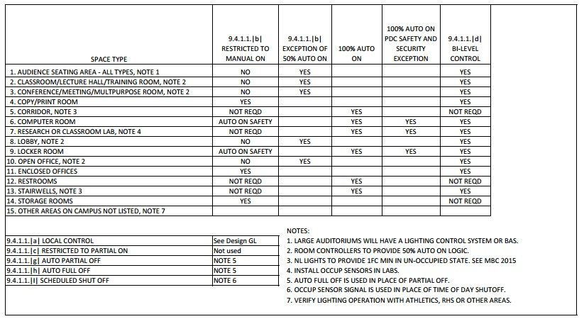

END OF SECTION 260923

