PAGE
TABLE OF CONTENTS 1

MECHANICAL 2
Summary
Design Process
Sustainability
Occupant Comfort
Load Calculations
HVAC
Refrigeration
Controls
Plumbing
Fire Protection
Access for Maintenance and Repair

MECHANICAL DESIGN
- SUMMARY
  - This section contains information which serves as general requirements for mechanical design. Refer to other guidelines as applicable to the project.
  - Refer to applicable codes and standards for further information on the criteria mentioned in this section. Where codes and standards are contradictory, follow the most stringent requirements.
  - Refer to Section of this document for mechanical space requirements and to appropriate sections of Divisions 21, 22 and 23 of the technical Construction Standards for additional design considerations.
  - References:
    - Americans with Disabilities Act (ADA), Public Law 101-336
    - ANSI/AIHA Z9.5, Laboratory Ventilation
    - ASHRAE Standard 15, Safety Standard for Refrigeration Systems
    - ASHRAE Standard 55, Thermal Comfort for Human Occupancy
    - ASHRAE Standard 62.1, Ventilation for Acceptable Indoor Air Quality
    - ASHRAE Standard 90.1, Energy Standard for Buildings Except Low-Rise Residential Buildings
    - Institute of Laboratory Animal Resource (ILAR)
    - Leadership in Energy & Environmental Design (LEED™) v3 for New Construction and Major Renovations
    - Michigan Boiler Code
    - Michigan Mechanical Code (MMC)
    - Michigan Plumbing Code (MPC)
    - Michigan Uniform Energy Code
    - Michigan Fire Safety Rules
    - Michigan Barrier Free Design
    - NFPA 13, Standard for the Installation of Sprinkler Systems
    - NFPA 14, Standard for the Installation of Standpipe, Private Hydrant, and Hoses Systems
    - NFPA 20, Standard for the Installation of Stationary Pumps for Fire Protection
    - NFPA 45, Standard on Fire Protection for Laboratories Using Chemicals
    - NFPA 90A, Standard for the Installation of Air Conditioning and Ventilating Systems
    - NFPA 101, Life Safety Code
    - Sheet Metal and Air Conditioning National Contractors Association (SMACNA)
- DESIGN PROCESS
  - General: The design process for major projects includes all phases as indicated below. The requirements as described herein are typical and may vary. Consult with MSU Infrastructure Planning and Facilities (IPF) / Planning, Design and Construction (PDC).
  - Program Phase: Include environmental program containing design indoor and outdoor conditions, heating and cooling degree-hours, applicable codes, etc. This phase is typically not required for purchase order projects.
  - Schematic Design Phase: Include environmental program containing design indoor and outdoor conditions, heating and cooling degree-hours, applicable codes, etc. This phase is typically not required for purchase order projects:
    - Code analysis and design criteria
    - System descriptions
    - Energy code compliance
    - Relative space requirement for equipment, ducts, and piping
    - Energy impact statement
    - Cost model
    - Schedule
    - Drawings including typical layouts and schematic diagram
    - Standard deviation log
    - Specification outline
  - Design Development Phase: Include system layouts for space requirements, revised cost estimates, and revised schedule. Provide a standard deviation log. This phase is typically not required for purchase order projects.
  - Contract Document Phase: Complete specification and drawings including typical details, schematic diagrams, hvac and plumbing piping matrix (refer to examples at end of guidelines) drainage/waste/vent riser diagrams, water riser diagrams, and control diagrams. Include a standard deviation log. Riser diagrams are not required for minor additions, alterations and renovations.
  - Construction Phase: Include shop drawing review, and periodic visits to the building under construction. This phase is optional for formal projects, and typically not required for purchase order projects.
  - Commissioning Phase: Include functional tests of all building systems.
  - Post-occupancy Services Phase: Include assistance to MSU Facilities Planning and Building Services in operating it for a period of at least six months after completion. This phase is optional. It may include adjustments and modifications to the HVAC systems.
- SUSTAINABILITY
  - The performance standard, LEED™ v3, shall be implemented to the extent feasible and practicable in all new buildings and major renovations in existing buildings. Refer to LEED™ in Design Guidelines – General Section for more information.
- OCCUPANT COMFORT
  - Thermal Comfort
    - Indoor temperature and humidity conditions must be in accordance with the comfort criteria established in ASHRAE 55.
    - Winter humidification and summer dehumidification are not typically required. When winter humidification is provided for comfort, a minimum relative humidity of 30% is generally acceptable.
    - Relative humidity for special areas such as computer rooms, research laboratories, etc., must not exceed 50%.
  - Ventilation
    - Offices, Classrooms, Auditoriums, etc.: Refer to ASHRAE 62.1
    - Teaching and Research Laboratories: Refer to NFPA 45 and ANSI Z9.5. Minimum ventilation rate must be 6 air changes per hour when occupied. Refer to MSU Design Guideline – Laboratory for additional requirements.
    - Animal Facilities: Refer to Institute of Laboratory Animal Resource (ILAR). Refer to MSU Design Guideline – Laboratory for additional requirements.
  - Noise and Vibration
    - Refer to ASHRAE Handbook – HVAC Applications for recommended Room Criterion (RC). Noise Criterion (NC) may be substituted if the quality of the sound in the space is of secondary concern.
- LOAD CALCULATIONS
  - Outdoor Design Conditions: Refer to ASHRAE Handbook – Fundamentals and ASHRAE 90.1 (* Consult with MSU to determine whether application is non-critical or critical).
    - Non-critical* Applications:
      - Heating @ 99.6%: -3º F DB
      - Cooling @ 1%: 86/72° F DB/MCWB
    - Critical*Applications:
      - Heating: -10º F DB
      - Cooling @ 0.4%: 89/74° F DB/MCWB
    - Evaporative Cooling: 78º F WB
  - Indoor Design Conditions: Occupied spaces, unless noted otherwise, shall be designed to maintain the following temperature and humidity levels:
    - Comfort Applications
      - Temperature: 75°F DB for cooling, 70ºF DB for heating
      - Relative Humidity: 30 – 60%
    - Process Applications:
      - Temperature: 72º ± 2° F DB
      - Relative Humidity 50% ± 5%
- HVAC
  - Zoning Consideration
    - Central heating and cooling systems must be used whenever practical since they are much more efficient than individual or package units.
    - Zones with substantially differing load characteristics must be served by separate air distribution systems.
    - One room per VAV box is preferred.
    - Spaces which might require operation 24 hours a day must be served by HVAC systems separate from systems for offices, which might require operation for only 8 hours a day, and classrooms, which might be shut down during summer.
    - Individual air conditioning units, fan coil units, and/or radiation must be provided in specific areas such as communication rooms, perimeter spaces, etc., to facilitate shut down of main HVAC units.
  - Heating Systems
    - Heating is usually accomplished through hot water perimeter systems using steam converters.
    - Reheat shall not be used in any constant volume HVAC system.
    - HVAC systems which require reheat for temperature or humidity control should utilize recovered heat for the reheat function.
    - Systems that blend refrigerated air and heated air for temperature control should not be used unless recovered energy is used for reheat.
    - Air handlers will normally be equipped with heating coils using steam as the heating medium. Steam coils are less susceptible to freeze-up than hot water coils. Vacuum breakers must be installed in the top of the steam supply headers, after the automatic control valves. All steam coils must be protected with automatic low limit control to shut off the fan to protect the coil from freezing.
    - In general, heat exchangers used as convertors for comfort heating must be of duplex or triplex type. Each convertor of duplex system must be sized for a 100% capacity. Each convertor of triplex system must be sized for a 50% capacity. Each convertor must be provided with parallel valves sized for 1/3 and 2/3 of its capacity.
    - The use of ceiling radiant heating system is acceptable in certain applications. However, use of finned-tube radiation for perimeter heating is preferred. Discuss with project PDC mechanical representative before designing around ceiling panels.
    - Do not provide bypass line around steam traps, control valves, and PRVs.
    - Discharge high-pressure condensate in a building to a low pressure system through flash tank when using Electric-driven steam condensate pumps or vented receiver of a pressure powered pump condensate recovery unit. Do not discharge condensate from varying pressures into a common return line or directly into a condensate pump discharge line.
    - Steam Systems
      - Operating pressures of the LP steam in existing building vary from 7 to 15 psig.
      - Operating pressures of the LP steam in new construction should be designed for 15 psig.
      - The set pressures of the safety valves should be 5 psi higher than the PRV reduced pressures.
      - LP drip traps should be selected for maximum operating pressure not less than relief valve set pressure.
      - Valves, strainers and fittings in HP shall be rated not less than 150 psi working pressure.
      - HP drip traps shall be selected for maximum operating pressure not less than150 psi working pressure
      - Steam traps on coils, heat exchangers, water heaters, e.g., should be selected for maximum operating pressure not less than the control valve inlet pressure.
      - Steam control valves should be selected for min. close off pressure not less than the control valve inlet pressure.
    - Steam Heating Coils
      - Standard steam distributing coils are suitable for applications involving little or no outside air heating requirement, where mixed air temperatures are assured to be above 40 degree F.
      - Integral face and by-pass steam heating coils must be used for all applications where large percentages of outside air are to be heated (mixed air temperature is below 40 degree F). Their non-freeze characteristics insure their continued reliability.
      - Provide adequate spacing between face and bypass steam heating coil and cooling coil to assure proper mixing of heated and bypassed air to prevent nuisance of tripping low limit control.
  - Ventilation Systems
    - Radioisotope hood exhaust system must be independent of other building exhaust system. Provision should be made for filters to be installed at hood outlet if required, and fan should be selected for recommended filter final resistance.
    - Perchloric exhaust system are not allowed. Contact MSU-EHS.
    - For ducted Biosafety Cabinets, thimble connected Class II Type A2 pressure independent connections are preferred to hard ducted Class II Type B2 connections. Where Class II Type B2 hard ducted biosafety cabinets are specified, they shall be exhausted by a dedicated fan.
    - Diversity factor of not less than 75% of maximum ventilation requirement for manifolded exhaust systems can be applied at system level, not at room level.
  - Air Conditioning Systems
    - Air-side economizer cycle must be used in all air handling systems to provide full cooling without the use of mechanical refrigeration whenever the outside temperature is lower than the required supply temperature.
    - Air system may be designed for high or low velocity. The chief justification for high duct velocity is space limitation. Return air ducts should be sized for low velocities. Hung ceilings for return plenums may be used.
    - For occupant comfort, the supply air should not be more than 20ºF. colder than the room temperature.
    - Reheat coils should be provided at the VAV terminals for both interior and perimeter spaces.
    - Dual duct systems are not preferred because of their high energy consumption.
    - The use of window air conditioners is not encouraged. Split systems or central air conditioning systems should be considered.
    - Provide twist timers and/or low ambient lockout devices for all air conditioners to prohibit the units from operating when the space is unoccupied and/or at low outdoor air temperatures.
    - Air conditioning system larger than 20 tons or requiring more than 20% outside air must be of chilled water type. DX cooling is not acceptable.
  - Air Distribution
    - Do not use ducts or plenums of masonry construction.
    - Do not use ceiling air plenum supply systems.
    - Pay particular attention to the fan style selection and ductwork arrangement at fan inlets and outlets to minimize pressure losses.
    - Draw and install ductwork as equalized to limit reliance on balancing dampers whenever possible.
    - Do not install ductwork through dedicated electrical rooms or spaces unless the ductwork is serving these areas.
    - Specify duct pressure class in accordance with SMACNA pressure classification equal to 150% of calculated static pressure for the section. Note that this is not the static pressure at which the fan is scheduled.
    - Duct liner shall not be installed in ductwork to avoid contamination from fiberglass duct lining. Sound attenuators may be used to ensure a quiet installation. If duct liner is required for further attenuation, use type with perforated metal interior.
  - Air Handling Units
    - The use of package roof top air handling units is not encouraged due to the difficulty of maintaining such units. If used, stair access to the roof must be provided.
    - Modular air handling units are generally used where sizes permit their selection. Access module must be provided between heating coil and cooling coil. When using plug fan module, a medium blank module should be provided between the coil and the fan for proper air distribution.
  - Fans
    - Direct drive fans are preferred over belt drive.
    - Use multiple fans in air handling units to provide redundancy. For fan arrays, use one VFD per two to three fans maximum.
    - ECM motors are a viable alternative.
    - Floor-mounted fans are strongly preferred. In-line centrifugal fans will be allowed on retrofit projects where lack of floor space is a factor, provided the fans are accessible for maintenance. Provide easy access for inspection, cleaning, service and removal of internal fan components for all in-line fans.
    - Do not locate general and toilet exhaust fans on roof. Locate fans inside the penthouse mechanical rooms. If exhaust fan is on roof, must use direct drive motor.
    - Locate fume hood exhaust fans outside the building or in a separate mechanical room that is maintained under slight negative pressure with respect to adjacent spaces. Do not locate these fans in the same mechanical room that houses the AHUs and other equipment.
    - Fan motors should be selected to operate against the filter final resistance.
    - Size the supply fan to handle the static pressure requirements of the higher of either 100% economizer operation or maximum return air operation.
  - Hydronic Systems
    - Piping systems must be designed for a friction loss rate no greater than 4.0 ft. of water per 100 equivalent feet of pipe.
    - Primary/secondary pumping designs are highly recommended for systems with large high pressure drop distribution systems.
  - Snow-melting Systems
    - Heated sidewalks over or near underground utilities must be avoided. Deviations must be reviewed with MSU IPF.
    - No permanent connection should be installed between the snow-melting system and domestic water supply.
    - Refer to Standard Details and Design Guidelines – Snowmelt for additional information.
  - Chemical Water Treatment
    - Provide shot type feeders and make up water lines on closed circuit hot water heating and chilled water systems without glycol.
    - For chilled water or snow melt system with glycol, provide feed line with hose bib connection with valve at 4’ AFF. Clearly label glycol feed line near hose connection. Shot feeders, make-up water lines, glycol storage tanks, make-up pumps, and low water level controllers are not needed.
    - Provide automatic chemical feed systems for condenser water systems.
    - Fill chilled water circuits of all exterior mounted chillers and/or chillers required to be operated in cold weather with a minimum 30% solution of ethylene glycol.
    - Locate tanks where chemicals can be easily transported, and within 20’ of the injection point. Provide water proofed, chemical resistance coated, depressed containment which is flush with floor and covered with grating on top. Consult with MSU IPF for sizing details.
    - Chemical treatment stations must be adequately lighted and ventilated.
    - An eyewash, safety shower, and hose bibb shall be provided in the chemical treatment area.
    - Install emergency shower and eyewash equipment in accessible locations within 100 feet from the chemical treatment stations.
    - Self-contained eyewash equipment (i.e., portable units), may be used at the glycol solution feed stations provided the following criteria are met:
      - It is not feasible to install a plumbed combination emergency shower with eyewash in renovation projects.
      - Self-contained eyewash equipment meets the American National Standards for Emergency Eyewash and Shower Equipment (i.e., ANSI Z358).
      - Self-contained eyewash equipment is accessible.
      - Self-contained eyewash equipment shall be maintained per the manufacturer’s instruction.
    - The appropriate PPE shall be maintained and worn properly when working with the glycol material.
- REFRIGERATION
  - General
    - Use zero CFC-based refrigerants. Minimize the use of HCFCs.
    - Air-cooled refrigeration equipment must be utilized wherever possible. Unless otherwise noted, no water-cooled refrigeration equipment utilizing domestic water is installed at MSU, including department owned laboratory apparatus which will waste a significant quantity of cooling water. Closed circuit condenser water systems, delivering 85° F. water, must be installed for water-cooled equipment. If certain equipment requires colder water, closed circuit process chillers must be installed.
    - A 125 volt, single phase, 15A receptacle outlet must be installed at an accessible location for the servicing of refrigeration equipment on rooftops and in attics and crawl spaces. The receptacle must be located on the same level and within 25 ft of the equipment. The receptacle outlet must not be connected to the load side of the equipment disconnecting means.
    - Source of potable hose bibbs must be provided nearby for all outdoor 10 ton and larger condensing/condenser units and cooling towers.
  - Condensers
    - Propeller fan style air-cooled condensers are normally installed outdoors. If job conditions prohibit such installation, centrifugal fan style condensers may be installed indoors in mechanical spaces.
    - Means must be provided to clean the finned surfaces of condenser coils. Outdoors, a source of potable water should be provided nearby (hose bibb). Indoors, the condenser should be provided with 50% efficient bag style air filters to keep the coil clean. If space conditions prohibit the air filters a source of potable water must be provided, with a drain pan under the entire condenser and the hose bibb area to contain the waste water and pipe it to drain.
  - Water Chillers
    - Discuss water chiller type with MSU-PDC project mechanical representative and refer to the Michigan State University Master Chilled Water Plan for chilled water type for particular location.
    - Select electric screw chillers for applications in 400 tons or less. Select single-stage absorption chillers for applications larger than 400 tons. For applications in larger than 1200 tons range, two-stage absorption chillers should be considered due to significant savings in operating cost. Electric or steam driven turbine chillers should be considered over absorption chillers. Provide a life cycle cost for options and review with PDC project mechanical representative.
    - Where loads exceed 500 tons and/or where great reliability is required, two equal sized units of the same model should be used. These units are generally piped parallel and have separate chilled and condenser water pumps with cross connected piping so one unit may operate alone. Control of units must be fully automatic with start-up initiated by an outside air temperature thermostat.
    - Steam fired absorption chillers produce very hot steam condensate, requiring special condensate pumps such as steam pressure powered pump. Condensate receivers must be vented to outdoors.
  - Cooling Towers
    - Process water requires year-round tower operation and reasonable water temperature control. Packaged centrifugal blower type towers have been used in this application, mounted indoors with control of inlet and discharge air through dampers. Process water cooling towers must be extremely reliable. Duplex pumps, each sized for 100% load, should be installed with isolation valves to allow pump repair without system shutdown. Split fan drive systems with two motors, and cold water make-up sufficient to carry partial load temporarily should be considered.
    - Indoor cooling towers must be applied and installed in such a manner so as not to cause a maintenance problem due to condensation on or around the unit. Provide separate air intake and discharge ductwork for the tower, not in common with building HVAC systems. Outside air intake dampers must be mounted where tower water will not wet air intake damper. This will prevent freezing of damper position. Dampers must be constructed of non-corroding materials.
    - Adequate cooling towers must be applied and installed in such a manner so as not to cause a maintenance problem due to condensation on or around the unit. Provide separate air intake and discharge ductwork for the tower, not in common with building HVAC systems. Outside air intake dampers must be mounted where tower water will not wet air intake damper. This will prevent freezing of damper position. Dampers must be constructed of non-corroding materials.
    - Cooling towers must be located at such distance and direction to avoid the possibility of contaminated tower discharge air being drawn into building fresh air intakes.
    - Architectural enclosures for aesthetic r ons should be considered for roof-mounted cooling towers.
    - Provide variable speed drives in lieu of bypass lines on cooling towers for the absorption chillers. Locate sensing devices near tower outlet.
  - Walk-in Freezers and Coolers
    - Condensing units for walk-in freezers and coolers must be installed in central location in the refrigeration/mechanical room and on floor mounted racks, not on top of the freezers/coolers. Air-cooled system is preferred. Provide electric defrost for unit coolers/freezers
- CONTROLS
  - General
    - All new buildings at MSU are to be connected to existing Central Energy Management System and must have temperature control systems of the “Direct Digital” type. Remodel projects in present buildings must extend the existing control systems in that building, whether pneumatic or EMS. Remodel projects that add a significant amount of new mechanical systems, such as chillers, air handlers, and converters, shall have temperature control systems of the “Direct Digital” type. Electric actuation is preferred. Pneumatic may be used in existing facilities or retrofits where appropriate. Consult with PDC prior to using pneumatic actuation.
    - Pneumatic controls may be used in alteration projects in existing buildings with pneumatic control system. DDC must be considered for new mechanical systems. Consult with MSU IPF / PDC.
    - Wireless controls may be considered for non-critical areas as approved by owner. All safety related controls must be hardwired.
  - Shutdown Controls
    - All nonessential fans must be shut off during unoccupied hours. On systems where the ventilating unit is the only source of heat, low limit zone thermostats should override the time clock to maintain minimum building temperatures.
    - Start and stop water chillers according to outdoor air temperatures. Necessary sensors must be installed to provide enthalpy control for building chillers.
  - Setback Controls
    - Day Un-occupied Mode: 78°F DB for cooling, 68ºF DB for heating.
    - Night Mode: Cooling system off, 55ºF DB for heating.
  - Economizer Controls
    - The intake of outside air should be minimized except when it can be utilized for cooling purposes. In areas where large amounts of outside air are required for limited periods of time such as anatomy labs, lecture rooms, etc., provide occupant control of outside air. This can usually be accomplished with an interval timer which will return the system to minimum outside air after a fixed period of time.
  - Ventilation Controls
    - For VAV systems, air flow measuring devices should be provided to measure outdoor airflow at the air handler and maintain outdoor airflow over the entire supply airflow operating range.
  - Zone Controls
    - The control system should be sequenced to prevent simultaneous heating and cooling.
    - Ventilating unit discharge temperatures should be reset as controlled by zone demand. This can be accomplished with room thermostats and load analyzers.
  - Heating Hot Water Controls
    - For constant air volume and/or perimeter heating only systems, reset heating hot water convertors and start and stop circulation pumps according to outdoor air temperatures.
- PLUMBING
  - Barrier Free Design
    - Americans with Disabilities Act (ADA), Public Law 101-336 must be followed as the standard in the design of accessible features in new construction and alterations.
    - Design must also be reviewed for compliance with the State of Michigan Barrier Free Design requirements. When there is a conflict, ADA must govern. When a Michigan requirement exists and ADA does not, the Michigan code must apply.
    - Remodeling work must also comply with the rules as near as possible. Deviations must be reviewed with the MSU University Engineer.
    - Toilet Stalls - Requires the 60 inch standard stall in new construction with the alternate stalls being allowed in existing. In large toilet rooms where six or more toilets stalls are provided, a 36 inch wide stall with parallel grab bars must be provided in addition to the standard stall required in new construction. If the 36 inch stall can be worked into the space of the existing toilet room, it should be included in the project.
    - Water Coolers - Wherever possible, replace the existing drinking fountains with the new dual height unit. If there is not room for dual unit, set the new fountain at the lower Handicap Height. In larger buildings, follow the code with the 50/50 split. Bottle fillers are preferred.
  - Water Supply and Distribution Systems
    - When conditions are such that University system water pressure will not be sufficient for outlet requirements, a water pressure booster station must be provided. Special attention must be given to penthouse equipment, such as stills, cooling tower make-up, etc., and also to flush valve operation at top floors of four story and taller structures.
    - Main shut off valves must be provided to allow isolation of entire rest room from the rest of the building.
    - Isolation valves must be conveniently located on branch lines so that segments can be taken off line quickly in the advent of failures.
  - Water Softening
    - In general, water softeners must be provided in individual buildings for hot water heaters and must be considered for condensing equipment and equipment such as stills, etc. Office type buildings with low hot water usage need not have softeners. Residence halls must have three softeners with two in service at all times. Normally both softeners are in service at once and are sized for regeneration about every 24 to 36 hours.
    - Water softeners must be provided for both cold and hot water systems of buildings located on the South side of Mt Hope Road which have very hard well water.
  - Sanitary Drainage Systems
    - Chemical waste system must be installed and designed as an independent sanitary drainage system. Consult with MSU Environmental Health & Safety (EHS) regarding the interconnection between the building sanitary drainage and chemical waste systems.
    - Building sanitary drain must discharge by gravity to the sanitary sewer. Avoid having water closets connected to building subdrain if the building subdrain does not drain by gravity into the sewer system.
    - Install floor drains as close as possible to equipment needing drains to prevent trip hazards. Consider housekeeping pads when evaluating locations as these may prevent proper drainage.
    - Indirect waste receptors shall not be installed above ceilings or in any inaccessible, concealed or unventilated area. If possible, these drains will be run to an area frequently used such as custodial closet.
  - Storm Drainage Systems: Secondary roof drainage must be completely independent of the primary roof drainage system.
  - Emergency Showers
    - In areas where whole body wetting is not required a hand operated hose spray (combination eyewash/drench hose) may be used. This should have a quick opening squeeze lever valve with a flow of at least six gallons per minute in a spray pattern. This spray may be located near the laboratory sink.
    - Floor drains must be provided with emergency showers.
    - Provide 60-95° F. water at the equipment. Refer to ANSI 358.1 for flow requirements.
    - Provide audible alarms or blinking lights to units in remote areas to indicate that the unit is in operation. Alarms are to be local, on electrical power rather than battery, and not on the emergency power system.
    - Consult with MSU EHS for emergency shower and eyewash locations.
  - Elevator Equipment Room
    - Drains connected directly to sewers shall not be installed in elevators pits.
    - Where drains are not provided in new or renovated elevator pit with a sprinkler head in it, sump pump shall be provided. Cover sump in pits. Level the cover with the pit floor. Install check valve on pump discharge as close to the pump as possible. Discharge through an air gap into a waste receptor. Size the pump large enough to handle at least the flow of a sprinkler head in the pit.
- FIRE PROTECTION
  - Wet Pipe Sprinkler Systems
    - Automatic sprinklers must be installed throughout all major buildings.
    - A sprinkler system with more than 20 heads must have an outside fire department connection placed near the loading dock, located between 18" and 48" above ground level. Reduced pressure type backflow preventers must be installed in the sprinkler systems having fire department connections.
    - When a portion of systems are subject to freezing, sprinklers must be installed as a dry-pipe system except for small unheated areas requiring less than 40 gallons. Antifreeze system must be used. Antifreeze solution must be propylene glycol. Reduced pressure type backflow preventer must be installed in the antifreeze system to prevent contamination of the potable water supply.
    - A/E to show on drawings the hydraulic reference points; description of sprinklers used; system design criteria including density, area of water application, and hose demand if applicable; actual calculated demand; and elevation data.
    - A common fire department connection may be provided to serve both the sprinkler system and a wet standpipe system. Consult with MSU Police for the location of the fire department connection.
  - Standpipe and Hose Systems
    - Standpipe must be installed in every building over two stories in height above the ground.
    - Dry standpipe and hose systems must be installed in open parking structures.
    - Standpipes must be four inches in size for any building six stories or under, and six inches in size for any building over six stories.
    - All standpipes must normally be wet, and located in stairwells. Intermediate standpipe risers may be needed in long buildings. The standpipe system within the building must be interconnected.
  - Fire Suppression Systems: No CFCs, HCFCs and Halon are used.
- ACCESS FOR MAINTENANCE AND REPAIR
  - All equipment shall have a minimum of 3’ clear on all sides and 6’8” headroom for service accessibility.
  - If air dampers, fire dampers, valves, etc., are located above fixed ceilings, access panels must be provided.
  - When equipment must be installed in relatively inaccessible locations, ladder or stairway shall be provided with proper loops, guards, and/or handrails. Openings in building construction to the equipment shall be not less than 2’ X 3’ in size and adequate lighting shall be provided at the equipment.
  - Access platform with ladder/stairway and guards/handrails should be provided to equipment mounted higher than 8’ above the floor.
  - When equipment must be mounted above the roof deck for airflow or roof maintenance considerations, a maintenance catwalk must be installed in the areas requiring service. This catwalk must be constructed of steel grating and must be complete with steps and handrail, all hot dip galvanized. The minimum height of structural frame legs shall be 24” for up to 24” width of equipment, 36” for 25” to 48” width, or 48” for 48” and wider width as recommended by National Roofing Contractors Association.
  - Maintenance catwalk on roof must be installed from the roof access to the roof-mounted equipment.
  - Indicate service clearances as recommended by the manufacturers for tube pull and coil replacement on drawing.

- HVAC PIPING AND PLUMBING MATRIX EXAMPLES

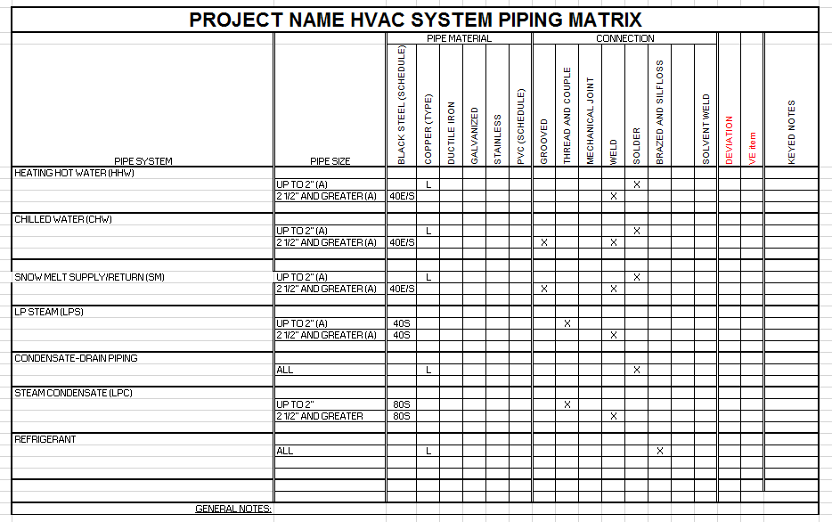

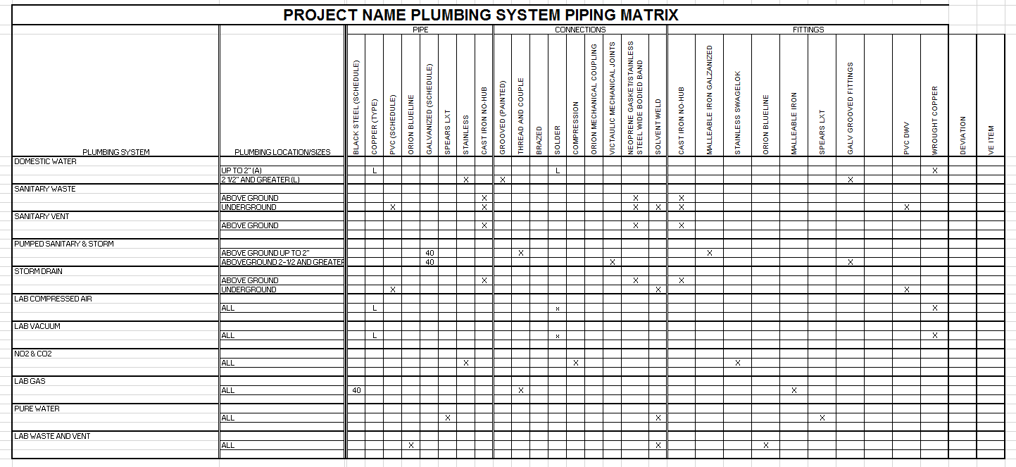

END OF SECTION

